All mosquito traps from summer 2017. Abundance standardized for time (3.5 hours)

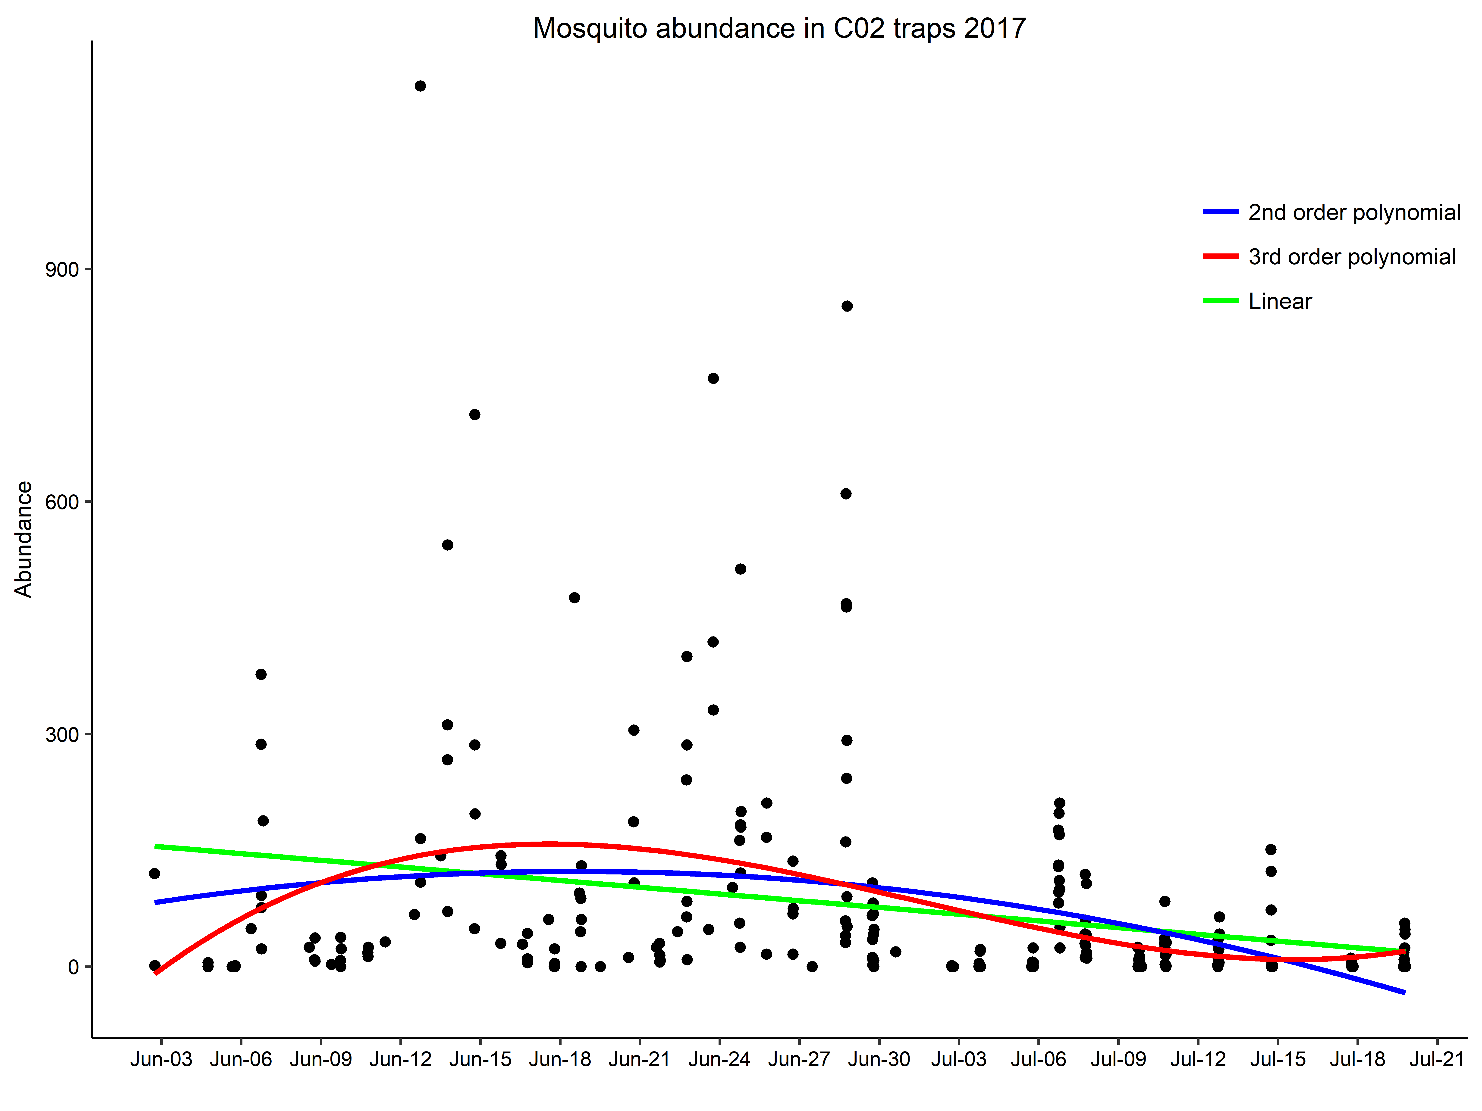

> aictable(rawaic,nR)

Params logL AICc deltaAICc weight cumwt

polynomial3 5 -1610.287 3230.815 0.000 0.9781 0.9781

polynomial2 4 -1615.163 3238.486 7.671 0.0211 0.9992

linear 3 -1619.477 3245.051 14.236 0.0008 1.0000

null 2 -1627.648 3259.344 28.529 0.0000 1.0000

Count data follow a zero inflated neg binomial distribution (second best neg. binomial)

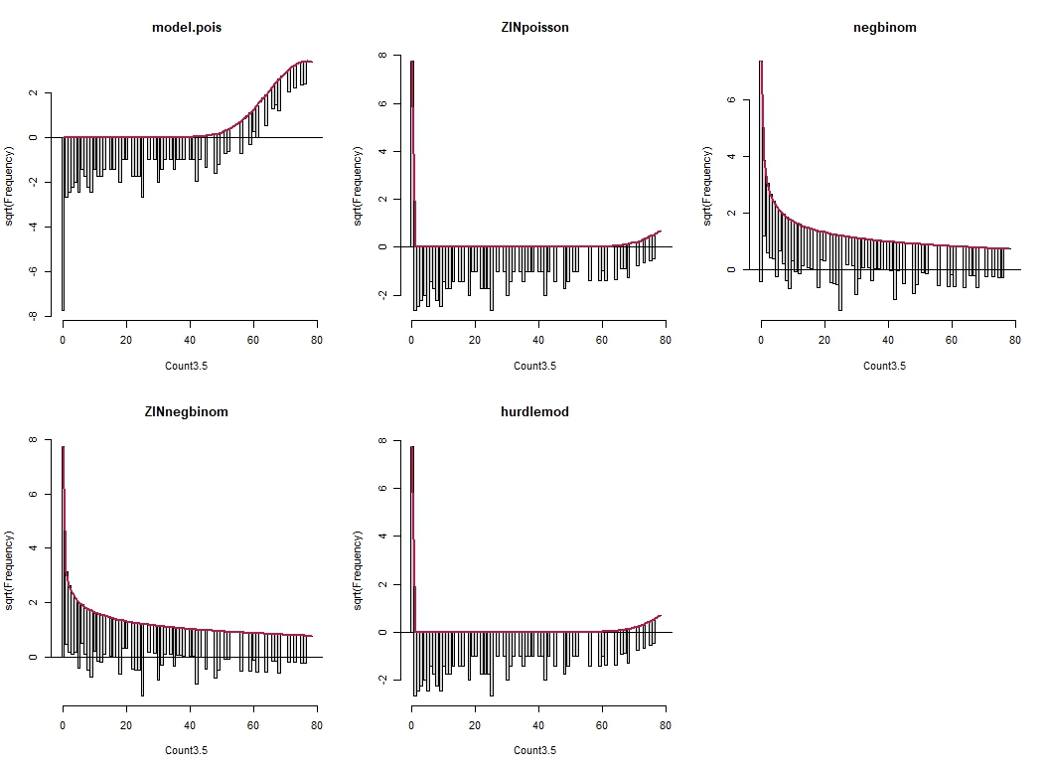

aictable(rawaic,nR)

Params logL AICc deltaAICc weight cumwt

ZINnegbinom 3 -1196.255 2398.605 0.0000 0.88 0.88

negbinom 2 -1199.271 2402.591 3.9856 0.12 1.00

null 2 -1627.648 3259.344 860.7390 0.00 1.00

hurdlemod 2 -16426.906 32857.859 30459.2542 0.00 1.00

ZINpoisson 2 -16426.906 32857.859 30459.2542 0.00 1.00

model.pois 1 -21582.176 43166.367 40767.7620 0.00 1.00

Extracted weather data from weather stations during trapping times.

Frequency histograms of weather variables during trapping times

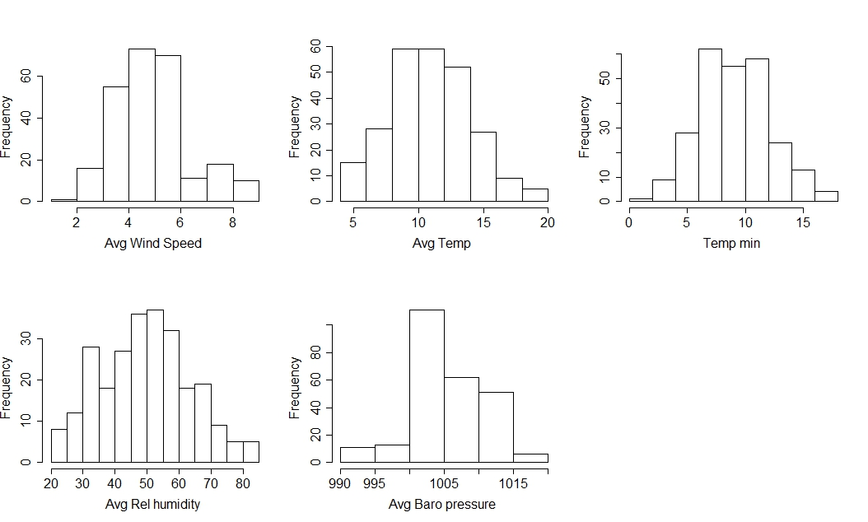

Correlations between weather variables (RH and temp are correlated, everything else looks okay)

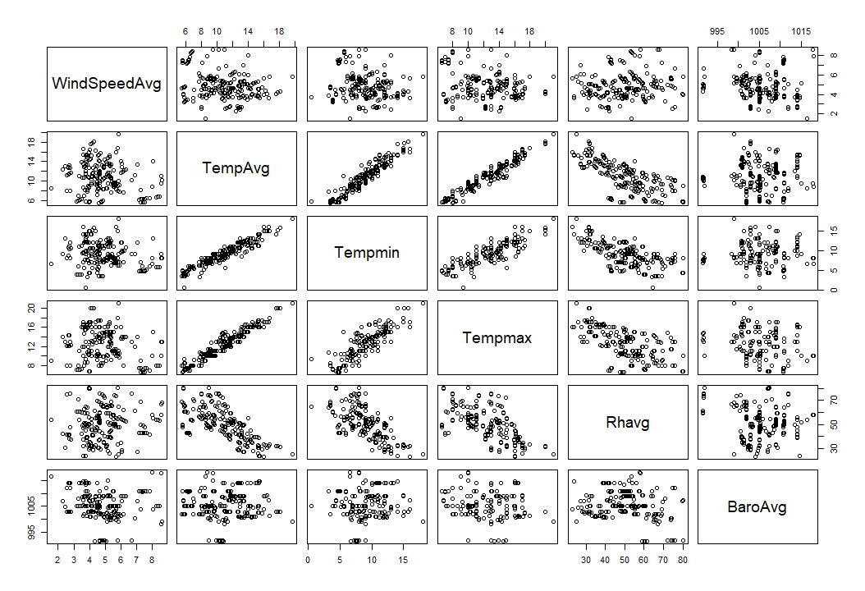

Linear or quadratic relationships with count data and weather data (USED NEG BINOM DIST)

> aictable(rawaic,nR)

Params logL AICc deltaAICc weight cumwt

**Tempminquad** 4 -1162.926 2334.012 0.0000 0.9920 0.9920

**Windquad**  4 -1168.458 2345.077 11.0652 0.0039 0.9959

Tempquad 4 -1168.770 2345.700 11.6888 0.0029 0.9988

Tempminlinear 3 -1170.938 2347.971 13.9592 0.0009 0.9997

Windlinear 3 -1172.154 2350.404 16.3918 0.0003 1.0000

Templinear 3 -1179.476 2365.048 31.0360 0.0000 1.0000

Tempmaxquad 4 -1181.866 2371.893 37.8809 0.0000 1.0000

Tempmaxlinear 3 -1188.181 2382.458 48.4460 0.0000 1.0000

**Rhlinear** 3 -1193.468 2393.032 59.0198 0.0000 1.0000

**Barolinear** 3 -1193.580 2393.256 59.2447 0.0000 1.0000

Rhquad 4 -1193.236 2394.632 60.6204 0.0000 1.0000

Baroquad 4 -1193.561 2395.283 61.2712 0.0000 1.0000

And date

> Timelinear<-glm.nb(Count3.5 ~ Date.num, data=C02weathertraptime)

> Timequad2<-glm.nb(Count3.5 ~ Date.num + I(Date.num^2), data=C02weathertraptime)

> Timequad3<-glm.nb(Count3.5 ~ Date.num + I(Date.num^2) +I(Date.num^3) , data=C02weathertraptime)

>

> rawaic<-AIC(Timelinear, Timequad2, Timequad3)

> nR<-dim(C02weathertraptime)[1] #Sample size

> aictable(rawaic,nR)

Params logL AICc deltaAICc weight cumwt

**Timequad3 5 -1176.862 2363.965 0.0000 0.7917 0.7917**

Timequad2 4 -1179.241 2366.642 2.6767 0.2076 0.9993

Timelinear 3 -1186.004 2378.103 14.1381 0.0007 1.0000

Results with Full model

> fullmodel<-glm.nb(Count3.5 ~ Date.num + I(Date.num^2) +I(Date.num^3) + Tempmin + I(Tempmin^2) + WindSpeedAvg + I(WindSpeedAvg^2)+ BaroAvg +Rhavg , data=C02weathertraptimesubset2)

> summary(fullmodel)

Call:

glm.nb(formula = Count3.5 ~ Date.num + I(Date.num^2) + I(Date.num^3) +

Tempmin + I(Tempmin^2) + WindSpeedAvg + I(WindSpeedAvg^2) +

BaroAvg + Rhavg, data = C02weathertraptimesubset2, init.theta = 0.6373344873,

link = log)

Deviance Residuals:

Min 1Q Median 3Q Max

-2.4256 -1.1464 -0.5683 0.2413 2.5153

Coefficients:

Estimate Std. Error z value Pr(>|z|)

(Intercept) -6.750e+02 2.929e+02 -2.304 0.021200 *

Date.num 1.242e+01 4.862e+00 2.554 0.010663 *

I(Date.num^2) -6.868e-02 2.755e-02 -2.493 0.012656 *

I(Date.num^3) 1.257e-04 5.190e-05 2.423 0.015413 *

Tempmin 9.010e-01 2.690e-01 3.350 0.000809 ***

I(Tempmin^2) -2.875e-02 1.138e-02 -2.526 0.011527 *

WindSpeedAvg -3.219e-01 7.502e-01 -0.429 0.667830

I(WindSpeedAvg^2) -3.602e-02 8.414e-02 -0.428 0.668596

BaroAvg -6.843e-02 2.338e-02 -2.927 0.003427 **

Rhavg 3.492e-02 1.196e-02 2.918 0.003518 **

---

Signif. codes: 0 ‘***’ 0.001 ‘**’ 0.01 ‘*’ 0.05 ‘.’ 0.1 ‘ ’ 1

(Dispersion parameter for Negative Binomial(0.6373) family taken to be 1)

Null deviance: 334.16 on 192 degrees of freedom

Residual deviance: 232.70 on 183 degrees of freedom

AIC: 1996.1

Number of Fisher Scoring iterations: 1

Theta: 0.6373

Std. Err.: 0.0618

2 x log-likelihood: -1974.1410

Mosquito abundance by weather variables

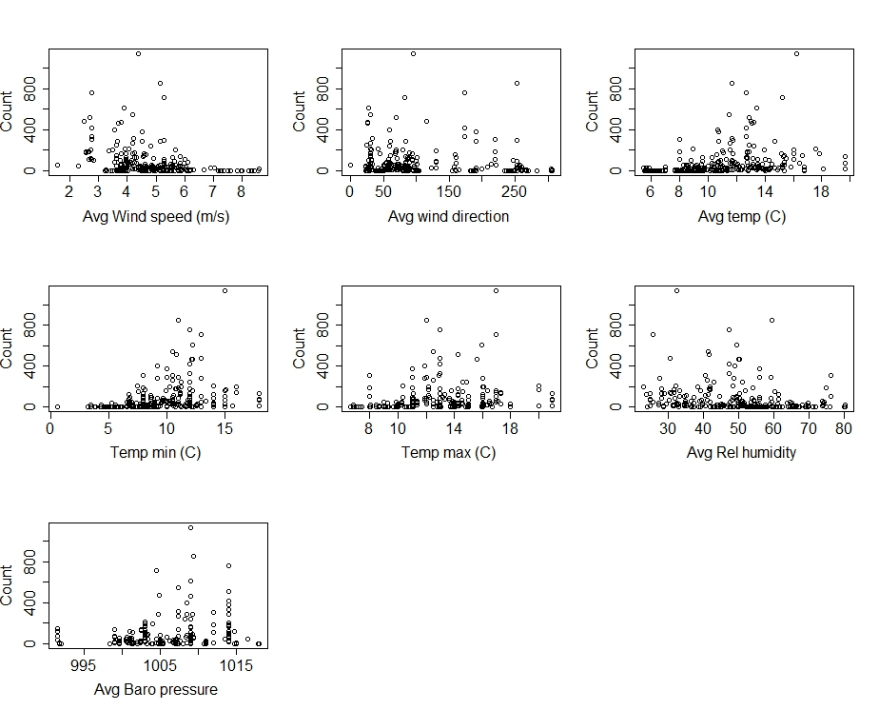

**Extracted residuals from GLM.NB model with Time (^3) plotted against weather**

#justtimemodel##

predNBtime <- predict(Timequad3, type="response")

predNBtime<-as.data.frame(predNBtime)

##

C02weathertraptime <- C02weathertraptime[order(C02weathertraptime$ID),]

C02trapresidualstime<-cbind(C02weathertraptime, predNBtime)

C02trapresidualstime <-mutate(C02trapresidualstime, resids1 = Count3.5-predNBtime)

